­­ 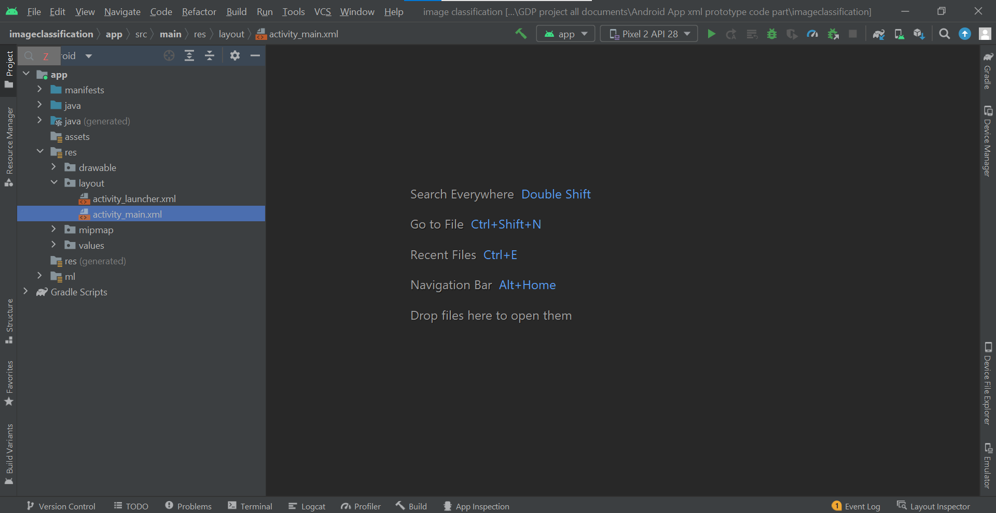

We have prepared the layout XML page. This page is one of the essential page since it is used to broadcast the actual presentation of the user interface for the developed application. The layout xml file is the composition of buttons, user interface elements along with text view elements. This layout XML page consist of two XML pages namely ***activity_launcher.xml and activity_main.xml***

The .xml pages used are based on the user interface with the image and text in it. On the right top we can see three buttons that are the code, split and design. If you click on the code part u get the representation of the coded document. If u click on the design part u get a two parted picturization.